Website Name: **Emaan Store**

Website Link: <https://store.miniisolutions.com/>

Created by: Abdul Wahab

Detail Document about **loading time,** **Images,** **Forms**.

**Loading Time:**

**Using Chrome,** we got total loading time of whole website is maximum 100ms.  
Here's the snapshot of loading time.

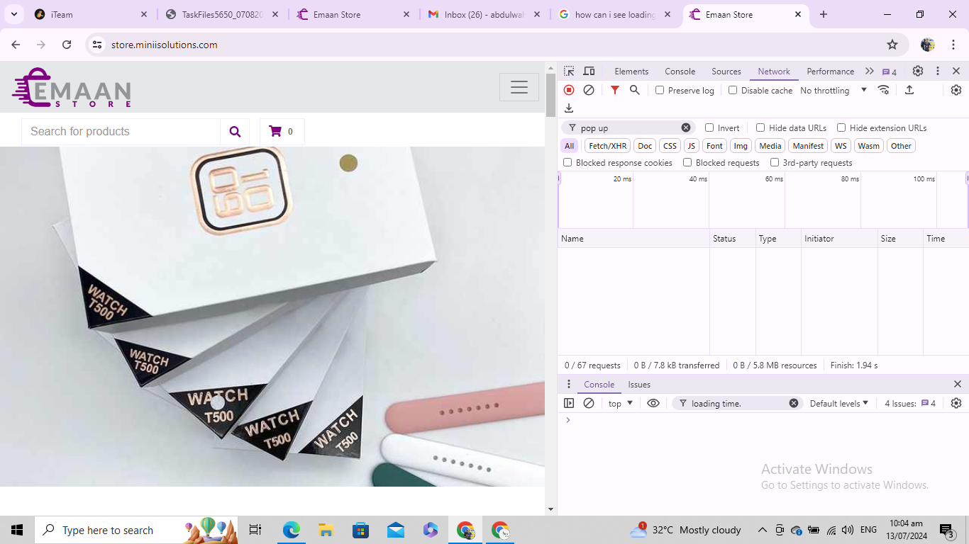

**By using MS Edge,** we got maximum loading time is 100ms.

Here’s the snapshot attached below:

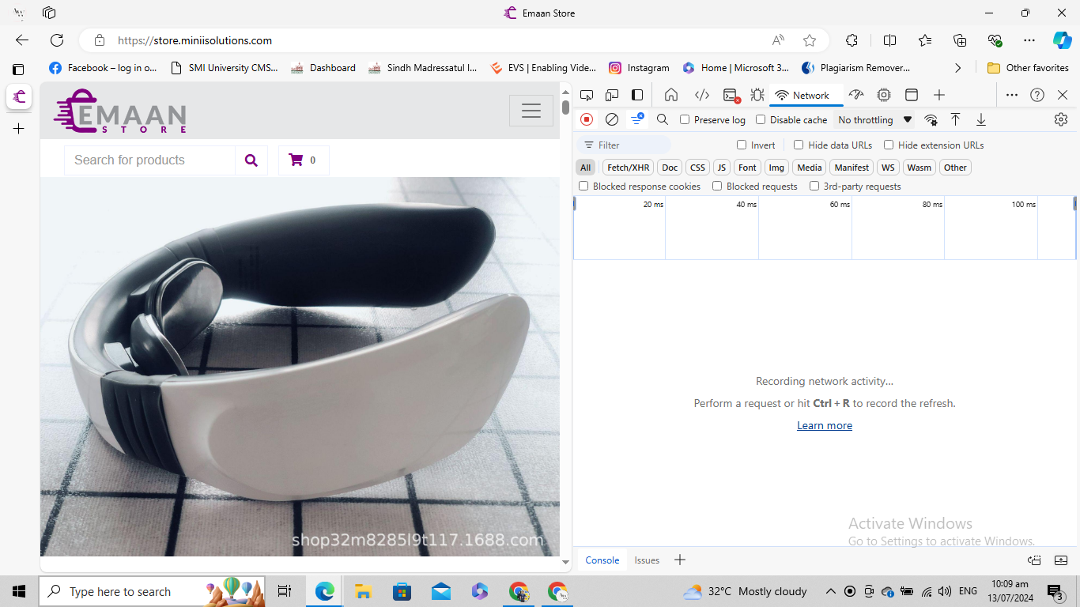

**In Mobile** it exactly opens in 100ms as open in chrome of laptop or edge or any other search engine.

The loading time of this website with its images and other features, is maximum 100ms all feature is easily load with i n 100ms. In any search engine or laptop, or mobile.  
  
**Images:**

* Loading time of all images of website is approx. 100ms as website loading time. All images visible and load easily and Fastly.
* All images quality is clear, images are clearly visible, accept one image is not place in his product place, product name is KOAO METALLIC LIPSTICK, this product images is not visible in any chrome or mobile. I attached the snapshot of it bellow,
* This problem faced in all devices and search engines.
* It Verifies that all images size is appropriate for website and it’s loading time.
* All images and its description are correct but there are some images which all related images descriptions are same.
* These all descriptions of images are incorrect.

**Forms:**

Testing all forms which are available in website.

**Newsletter form** works properly input data is; Name: Abdul Wahab

Email: [abdulwahab@gmail.com](mailto:abdulwahab@gmail.com)

While inputting invalid credentials it works correctly here’s the snapshot of putting input credentials.

* This form of newsletter works properly.

**Business With us Form**

This form is not functional and not allows you to submit while putting input. Here’s the snapshot of given credentials.  
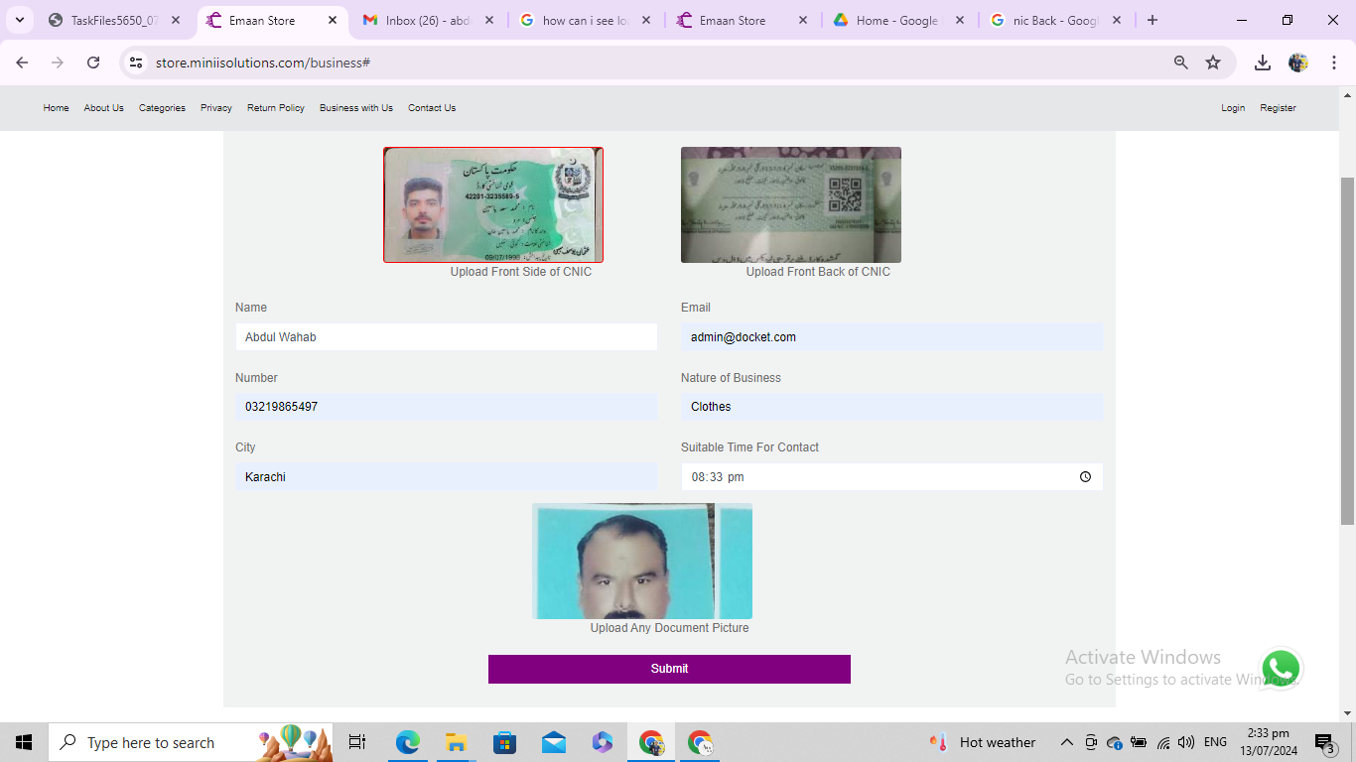

This form gives issue it’s not working. Means it's not functional.

**Contact Us Form,** this form is not visible, it means it’s not functional, attached the video bellow,

[For Video click here](https://drive.google.com/file/d/1_cop2r2CuLR2ETf1F6RlSnvMcYq-33Nl/view?usp=sharing)

**Login Functionally** i tested it while inputting invalid credentials it gives error.

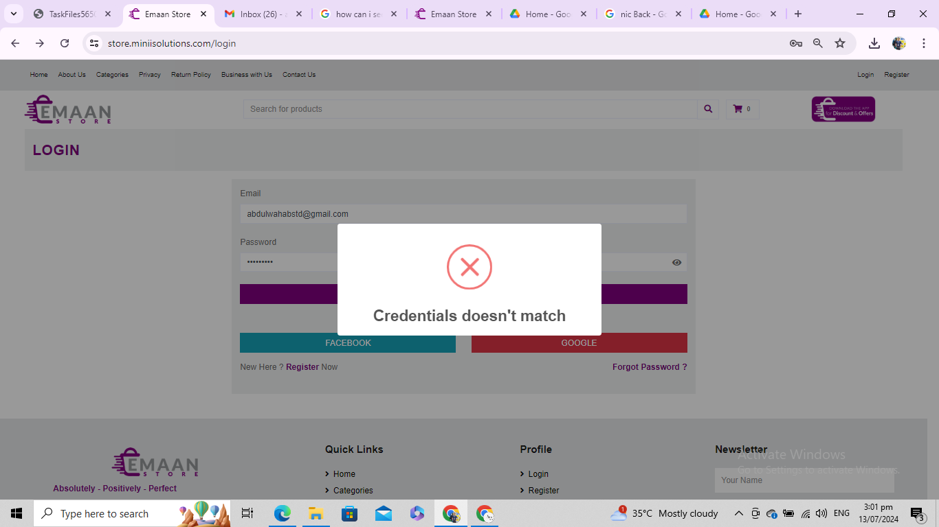

**Register Form** by inputting information it does not work it means it's not functional.

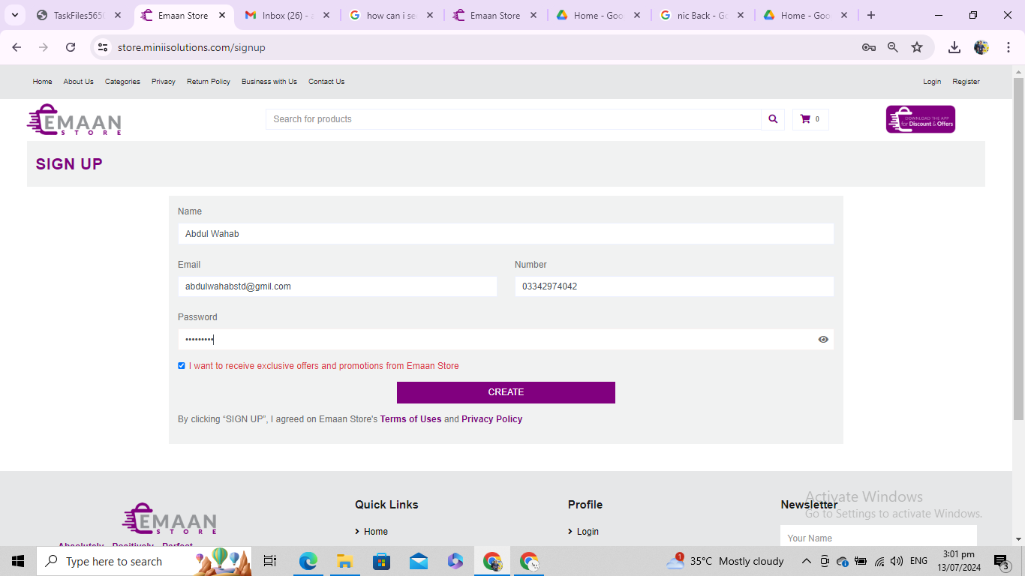

While I press a create button after inputting data but it doesn't move towards next screen. It means it’s not functional.

**Summary:**

Above all information includes loading time of images, and website in different devices and different search engine and for supporting purpose i added videos, and images in it.